目录

1 Hyperledger Explorer Integration 1

# 1 Hyperledger Explorer Integration

<https://github.com/hyperledger/blockchain-explorer>

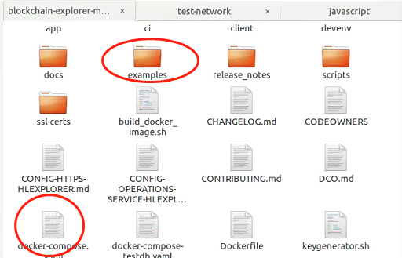

Copy to test-network folder

Replace the right config in connection-profile

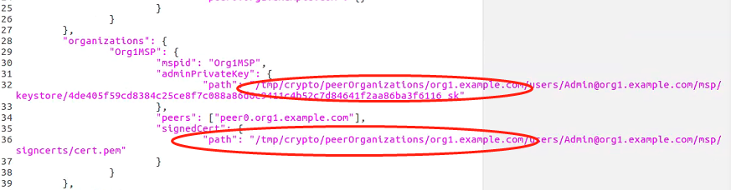

Sudo docker-compose up to start the HyperExplorer

npm install sqlite3

npm install md5

# Request

## 2.1 Get request

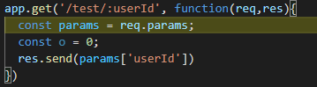

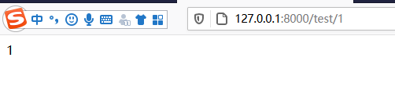

## 2.2 Put request

